RAVINDRA COLLEGE OF ENGINEERING FOR WOMEN
Department of Computer Science and Engineering

PROJECT REPORT :
AI Based Human Development Index (HDI) Prediction System
Submitted by :
Syeda Fasiha Zareen [Team Leader]
DUDEKULA CHERRYSHMA BANU [Team Member]
Thamadapalli Chinna Madhavi [Team Member]
Mucchala Deekshitha Reddy [Team Member]
Uma Maheswari Korrapati [Team Member]

Under the Guidance of

Mr./Mrs. ___________

Department of Computer Science and Engineering
RAVINDRA COLLEGE OF ENGINEERING FOR WOMEN
2025–2026

CERTIFICATE

This is to certify that the project report entitled "AI Based Human Development Index Prediction System" is a bonafide work carried out by Syeda Fasiha Zareen, DUDEKULA CHERRYSHMA BANU , Thamadapalli Chinna Madhavi , Mucchala Deekshitha Reddy , Uma Maheswari Korrapati (Roll No.233TA05068, ) in partial fulfillment of the requirements for the award of the degree of Bachelor of Technology in Computer Science and Engineering, submitted to RAVINDRA COLLEGE OF ENGINEERING FOR WOMEN during the academic year 2025–2026.
It is further certified that this work has been carried out under my supervision and guidance and that it has not been submitted, either in part or in full, to any other university or institution for the award of any degree or diploma.

Place: ___________________
Date: ____________________
Faculty Signature ______________________
Head of Department ______________________

ACKNOWLEDGEMENT
I express my sincere gratitude to my project guide, Mr./Mrs. ____________________, for the valuable guidance, continuous encouragement, constructive suggestions, and constant support throughout the development of this project titled "AI Based Human Development Index Prediction System." Their expertise, patience, and motivation played a significant role in the successful completion of this work.
I extend my heartfelt thanks to the Head of the Department of Computer Science and Engineering for providing the necessary facilities and encouragement to carry out this project successfully.
I am also grateful to the Principal of ____________________ College for providing an excellent academic environment and the resources required for completing this project.
I would like to thank all the faculty members of the Department of Computer Science and Engineering for their valuable suggestions, encouragement, and support throughout the course of this project.
Finally, I express my deepest gratitude to my parents, family members, and friends for their unconditional support, encouragement, and motivation, which helped me overcome challenges and successfully complete this project.
I sincerely thank everyone who directly or indirectly contributed to the successful completion of this project.

INTRODUCTION
The Human Development Index (HDI) is a statistical measure developed by the United Nations Development Programme (UNDP) to evaluate and compare the overall development of countries. It measures development based on three important dimensions: health, education, and standard of living. These dimensions are represented by indicators such as Life Expectancy, Mean Years of Schooling, Expected Years of Schooling, and Gross National Income (GNI) Per Capita. HDI helps governments, researchers, and policymakers understand the social and economic progress of different countries and identify areas that require improvement.
With the rapid growth of Artificial Intelligence (AI) and Machine Learning (ML), it has become possible to analyze large datasets and make accurate predictions in a shorter time. Machine Learning algorithms can identify hidden patterns in historical data and use them to predict future outcomes. These technologies are widely used in various fields such as healthcare, finance, education, agriculture, and economics.
The AI Based Human Development Index (HDI) Prediction System Using Machine Learning is developed to predict the HDI score based on key socioeconomic indicators. The project uses the Random Forest Regression algorithm, which is known for its high prediction accuracy and ability to handle complex datasets. The model is trained using historical HDI data and then integrated into a Flask-based
This project not only highlights the importance of Artificial Intelligence in solving real-world problems but also provides students with practical experience in data preprocessing, model training, web application development, and Machine Learning deployment. It serves as an educational tool for understanding how data-driven technologies can be used to support decision-making and development analysis.
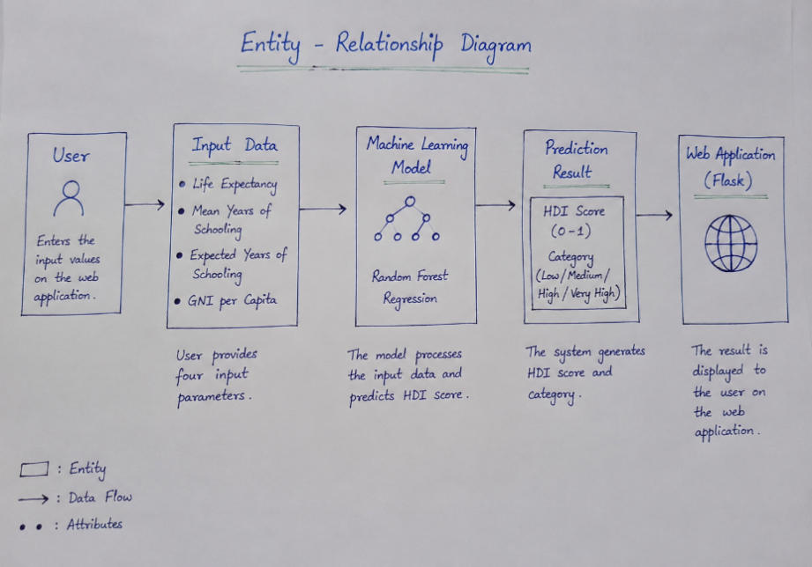

Step 1: Collect HDI Dataset
The first phase of the project involves collecting a reliable dataset that contains historical Human Development Index (HDI) information. The dataset used in this project is **`hdr_general.csv`**, obtained from publicly available Human Development Reports. The dataset contains information about different countries and their development indicators over multiple years.
The major attributes present in the dataset include:
* Life Expectancy
* Mean Years of Schooling
* Expected Years of Schooling
* Gross National Income (GNI) Per Capita
* Human Development Index (HDI)
These features represent the three major dimensions of human development:
* Health
* Education
* Standard of Living
The collected dataset serves as the foundation for training the Machine Learning model. The quality and reliability of the dataset directly influence the accuracy of the prediction system.
Importance of Dataset Collection
* Provides historical information for model training.
* Helps identify relationships among development indicators.
* Improves prediction accuracy.
* Serves as the knowledge base for the Machine Learning algorithm.
Step 2: Data Preprocessing
Raw datasets often contain missing values, duplicate records, incorrect data formats, and unnecessary attributes. Therefore, data preprocessing is one of the most important stages of the project.
In this step, the dataset is cleaned and prepared before it is used for training the Machine Learning model.
The preprocessing activities include:

Removing Missing Values
Some rows may contain empty or null values. Such records are either removed or handled appropriately to prevent inaccurate predictions.

Selecting Important Features
Only the relevant features required for HDI prediction are selected.
Selected Features:
* Life Expectancy
* Mean Years of Schooling
* Expected Years of Schooling
* GNI Per Capita
Target Variable:
* HDI Score
Data Validation
The dataset is checked to ensure that numerical values are stored correctly and that no invalid records remain.

Benefits of Data Preprocessing
* Improves model accuracy
* Reduces training time
* Removes noisy data
* Prevents prediction errors
Proper preprocessing ensures that the Machine Learning model learns meaningful patterns rather than incorrect information.
Step 3: Split Dataset into Training and Testing Data
After preprocessing, the dataset is divided into two separate parts.
Training Dataset
Approximately **80%** of the dataset is used for training the Machine Learning model.
During this stage, the model learns the relationship between input parameters and the HDI score.
Testing Dataset
The remaining **20%** of the dataset is reserved for testing.
The testing dataset contains records that the model has never seen before.

Using unseen data helps evaluate whether the model can make accurate predictions for new users.
Advantages of Train-Test Split
* Prevents overfitting.
* Evaluates model performance.
* Improves reliability.
* Measures prediction accuracy.
The `train_test_split()` function from Scikit-learn is used to perform this operation.

Step 4: Train the Machine Learning Model
After splitting the dataset, the training data is used to build the prediction model.
The algorithm selected for this project is **Random Forest Regression**.
Random Forest is an ensemble Machine Learning algorithm that combines multiple Decision Trees.
Instead of relying on one tree, it builds many trees and averages their outputs.
This approach produces:
* Higher accuracy
* Better stability
* Lower overfitting
* Improved prediction performance
Training Process
The algorithm receives four input parameters:
* Life Expectancy
* Mean Years of Schooling
* Expected Years of Schooling
* GNI Per Capita
The target value is:
* HDI Score
The model repeatedly analyzes the dataset until it learns the relationship between inputs and outputs.
After successful training, the model becomes capable of predicting HDI for unseen data.

Step 5: Save the Trained Model
Training the model requires computational time.
To avoid retraining every time the application starts, the trained model is saved using the **Joblib** library.
The model is stored as:
hdi_model.pkl
The saved model contains all the knowledge learned during training.
Whenever the Flask application starts, this file is loaded directly.
Advantages
* Faster prediction
* No need for repeated training
* Efficient memory usage
* Easy deployment
Saving the trained model significantly improves application performance.

Step 6: Develop Flask Web Application
Once the Machine Learning model is ready, it is integrated with a Flask web application.
Flask is a lightweight Python web framework that allows communication between the user interface and the Machine Learning model.
The application consists of two major components:
Frontend
Developed using:
* HTML
* CSS
The frontend provides a simple interface where users enter HDI-related information.
Backend
Developed using:
* Flask
* Python
The backend performs the following tasks:
* Receives user input
* Loads the trained model
* Performs prediction
* Sends the result back to the webpage
This architecture makes the application easy to use and highly interactive.
Step 7: User Input
The user accesses the web application through a browser.
A prediction form is displayed.
The user enters:
* Life Expectancy
* Mean Years of Schooling
* Expected Years of Schooling
* Gross National Income (GNI) Per Capita
These values are collected through HTML forms.
Before sending the data to the Machine Learning model, Flask validates the inputs to ensure that numerical values are entered correctly.
After successful validation, the values are forwarded for prediction.

Step 8: Prediction Process
When the **Predict HDI** button is clicked, the Flask application performs several operations.
First, it loads the saved Machine Learning model (`hdi_model.pkl`).
Next, the user input values are converted into the required numerical format.
These values are passed to the Random Forest Regression model.
The model analyzes the input and predicts the corresponding HDI score.
The prediction process takes only a fraction of a second, making the system highly efficient and user-friendly.
Step 9: Display Prediction Result
After the prediction is completed, the result is displayed on the web page.
The application shows:
* Predicted HDI Score
* Human Development Category (Low, Medium, High, or Very High)
* Prediction Time
* Progress Bar
The result page provides a clear visualization of the prediction so that users can easily understand the development status represented by the calculated HDI value.
The web interface is designed to be simple, attractive, and responsive, ensuring that users can interact with the application without technical knowledge.
Here's a professional Conclusion that matches your HDI project and is suitable for a B.Tech project report.
CONCLUSION
The AI Based Human Development Index (HDI) Prediction System Using Machine Learning was successfully designed and developed to predict the Human Development Index using important socioeconomic indicators such as Life Expectancy, Mean Years of Schooling, Expected Years of Schooling, and Gross National Income (GNI) Per Capita. The project demonstrates how Machine Learning can be applied to solve real-world problems by providing quick and reliable predictions based on historical data.
In this project, the dataset was collected, preprocessed, and divided into training and testing datasets. The Random Forest Regression algorithm was selected because of its high prediction accuracy, robustness, and ability to handle complex datasets effectively. After training, the model was saved using the Joblib library and integrated into a Flask-based web application. The application provides a simple and user-friendly interface where users can enter the required values and instantly obtain the predicted HDI score along with its corresponding development category.
Overall, the project achieved all its objectives and successfully demonstrates the use of Artificial Intelligence and Machine Learning in socioeconomic analysis. The knowledge gained during this project enhanced our understanding of data preprocessing, model training, Machine Learning algorithms, web application development, and model deployment. This project can be further improved by using larger datasets, incorporating additional development indicators, and deploying the application on cloud platforms to provide wider accessibility and better prediction performance.

REFERENCES
- United Nations Development Programme (UNDP), "Human Development Reports", Available at: https://hdr.undp.org/
- Python Documentation, "Python Programming Language", Available at:
https://www.python.org/doc/
- Scikit-learn Documentation, "Machine Learning Library for Python", Available at:
https://scikit-learn.org/
- Flask Documentation, "Web Development Framework", Available at:
https://flask.palletsprojects.com/
- World Bank Open Data, "Development Indicators Database", Available at:
https://data.worldbank.org/
- James, G., Witten, D., Hastie, T., Tibshirani, R., "An Introduction to Statistical Learning", Springer.

